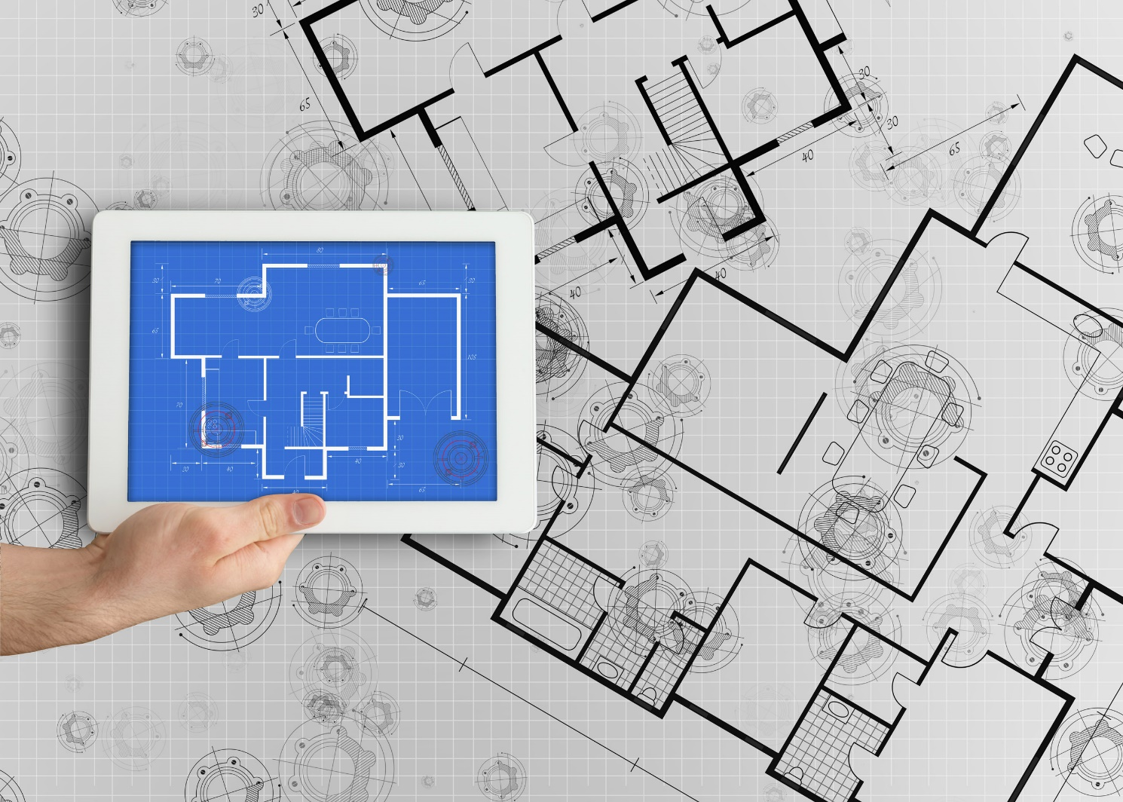

**Integrated Supplier Transaction Guideline**

December 2021

**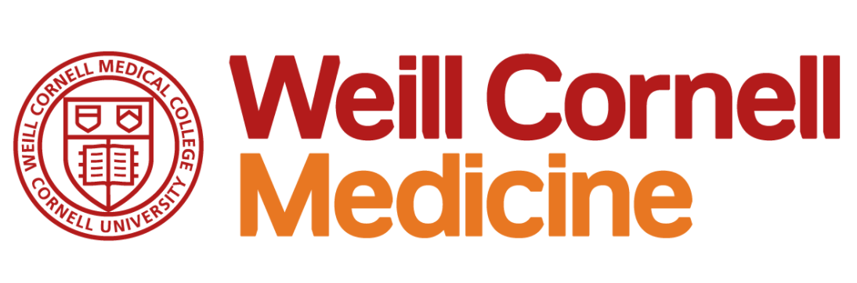**

Table of Contents

[Version History 3](#_Toc89810720)

[Weill Cornell Medicine Mapping Requirements and Deltas 4](#_Toc89810721)

[Weill Cornell Medicine Detailed Specifications and Requirements 6](#_Toc89810722)

[Scope 6](#_Toc89810723)

[Purchase Order Details 6](#_Toc89810724)

[Order Confirmation Details 7](#_Toc89810725)

[Ship Notice Details 7](#_Toc89810726)

[Invoice Details 7](#_Toc89810727)

[Supplemental Documentation 9](#_Toc89810728)

[SAP Ariba customer Support for Suppliers 10](#_Toc89810729)

# Version History

This log is updated each time this Process Document is updated. The log identifies the version number, the date the version was completed, the author of the changes, and a brief description of the changes.

|  |  |  |  |
| --- | --- | --- | --- |
| Version | Date | Author | Description |
| 1.0 | 12/2021 | Angie Albertson – SAP  Matt Dallas – SAP | Initial Version of Document |

# Weill Cornell Medicine Mapping Requirements and Deltas

**Deltas**

In the following excel workbooks you will find baseline cXML and EDI transactions accepted by the Ariba Network with the additional requirements for Weill Cornell Medicine noted in **blue.**

**cXML Delta:** ** **EDI Delta**: **  
The following is a summary of the requirements that are unique to Weill Cornell Medicine’s procurement environment, as detailed in the Excel Delta’s document.

**Purchase Order Specifics (Tab 1)**

* Change and Cancel POs in scope
* Catalog, Non-Catalog, and Service orders in scope
* Non-Catalog orders may use quote number as part ID
* Ship To address will be sent at the header level and will contain Ship To IDs
* Deliver to address will be sent at the header level and will contain first and last name
* Payment terms will be sent on all POs
* Attachments may be used, especially with quote related orders

**Order Confirmation Specifics (Tab 2)**

* Required
* Delivery dates are required
* Reason must be provided for Rejection
* Comments are Required for any changes compared to PO

**Ship Notice Specifics (Tab 3)**

* Optional
* Shipping dates are required
* Delivery dates are required
* Carrier name and Tracking number is not required but encouraged

**Invoice Specifics (Tab 4)**

* Partial Invoices allowed
* Invoice Numbers can have a max length of 16 characters.
  + Special Characters Allowed
  + Invoice numbers cannot be reused
* Service Invoices in scope but no Service Entry Sheet needed
* Non-PO Invoices not in scope
* Cancels allowed
* Bill To ID and Address Required, Ship To ID and Address Required, Ship From address required
  + If Sold To party used, the Name and Country must match the Bill To from the PO
* Payment terms cannot be changed but can be omitted
* Backdating and future-dating not allowed
* Quantity must be greater than zero
* Item Descriptions Required
* All orders are Tax Exempt
* Shipping and Special Handling are supported at Summary level

**Line-Level Credit Memo (Tab 5)**

* Line Level Credit memo is in scope
* Reference to original invoice recommended
* Contains negative quantity and summary amounts with positive unit prices in cXML
* Contains positive quantity, line-level unit price, and summary amounts for EDI

**Transaction Validation Rules**

Please note, Weill Cornell Medicine has configured custom validation rules on the Ariba Network which apply specifically to POs, Order Confirmations, Ship Notices. **Review these settings from your supplier account on the Ariba Network**.

# Weill Cornell Medicine Detailed Specifications and Requirements

## Scope

Weill Cornell Medicine Prod ANID: AN01688851753

Weill Cornell Medicine Test ANID: AN01688851753-T

Required Transactions

* + Purchase Order
  + Invoice
  + Order Confirmation

**Optional Transactions**

* + Advanced Ship Notice

## Purchase Order Details

|  |  |
| --- | --- |
| Purchase Order Types Supported | Purchase Order Types Not Supported |
| Catalog | Blanket POs (BPO’s) |
| Change/cancel POs | PCard POs |
| Non-catalog POs | Legacy POs |
| POs with attachments |  |
| Service POs |  |
|  |  |

Table 1 - Purchase Order Types Supported/Not Supported

**Ship To Address**

* + Weill Cornell Medicine POs will send Ship To address at header
  + Weill Cornell Medicine POs will include Ship To address IDs.
  + Weill Cornell Medicine POs will use the Deliver To field

## Order Confirmation Details

Weill Cornell Medicinedoes not require Order Confirmation. Supported methods of providing them are:

* + cXML
  + EDI
  + Online
  + Email to requestor outside of Ariba Network

## Ship Notice Details

Weill Cornell Medicinedoes not require Advanced Ship Notices. Supported methods of providing them are:

* + cXML
  + EDI
  + Online
  + Email to requestor outside of Ariba Network

## Invoice Details

|  |  |
| --- | --- |
| Invoice Types Supported | Invoice Types Not Supported |
| Individual Detail Invoice: applies against a single PO referencing line items; line items may be material items or service items. | Non-PO Invoice: invoice against PO not transacted via the Ariba Network |
| Partial invoice: Invoice against a portion of the items on a PO. | Non-PO invoice against contract or master agreement |
| Invoice against material PO | Invoice against Blanket PO |
| Invoice against service PO | Header Credit Memo |
| Line level credit supported by negative quantity at item level and positive unit price | Debit Memo |
| Cancel Invoice | Duplicate Invoice: invoice numbers may be reuse in case of reject/fail/cancel of original invoice |
|  | Header Invoice: single invoice applying to single PO without item details |
|  | Invoice against PCard |
|  |  |

Table 2 - Invoice Types Supported/Not Supported

**Tax Requirements**

* All Orders are Tax Exempt

**Remit To Address Information**

* Remit To address information is not required on the invoice.

**Shipping and Special Handling Fees**

* Shipping and special handling charges are supported at the summary level.

**Line Level Validation**

* The following line level data cannot be changed from PO to Invoice.
  + Currency for Unit Price
  + Unit Price
  + Unit of Measure
  + Quantity
  + Part Number
  + Sub Total

# Supplemental Documentation

This document contains Weill Cornell Medicinespecific information regarding transaction requirements. Information in this document does not cover the complete technical aspects of integrating with the Ariba Network.

Below are three sections for supplemental documentation to be used with this document for cXML, EDI x12 or PIDX transaction formats. Only refer to the section that pertains to the format your organization with be sending or receiving.

**cXML Supplemental Documentation**

New cXML supplier to Ariba Network must:

1. Support a DTD (document type definition) validation tool internally and download the document type definitions (DTD’s) for all supported transactions.
2. Support HTTPS protocol. Ariba supports HTTPS (not HTTP) only for cXML transactions.
3. Review the cXML Solutions Guide and cXML User Guides.

**cXML Document Type Definitions (DTD’s)**

* [http://cxml.org](http://cxml.org/) Download [InvoiceDetail.zip](http://xml.cxml.org/current/InvoiceDetail.zip) for the InvoiceDetailRequest.dtd.
* <http://cxml.org> Download cXML.DTD for the OrderRequest
* <http://cxml.org> Download Fulfill.dtd for ConfirmationRequest/ShipNoticeRequest

**SAP Ariba Cloud Integration Gateway (CIG)**

Information in this document does not cover the complete technical aspects of integrating with the SAP Ariba Cloud Integration Gateway (CIG).

Below is a list of supplemental documentation to be used with this document for CIG connectivity, CIG EDI x12 and PIDX transaction file formats. These documents can be viewed or downloaded from the CIG Resource Portal. How to login to [SAP Cloud Integration Gateway](https://help.sap.com/viewer/76c114b292d84c379d1626cff721acec/cloud/en-US/12c97457e7494a35ba53d84a1c6e0554.html).

**New Cloud Integration Gateway Supplier**

* Cloud Integration Portal Guide (aka. CIG “How to Guide”)

**EDI x12 Supplemental Documentation via SAP Ariba Cloud Integration Gateway**

* SAP Ariba PO850 4010 Purchase Order
* SAP Ariba PC860 4010 Purchase Order Change
* SAP Ariba PR855 4010 PO Acknowledgment (Order Confirmation)
* SAP Ariba IN810 4010 Invoice
* SAP Ariba SH856 4010 Ship Notice
* SAP Ariba RA820 4010 Remittance Advice
* SAP Ariba AG824 4010 Application Advice (inbound)
* SAP Ariba AG824 4010 Application Advice (outbound)
* SAP Ariba FA997 4010 Functional Acknowledgment (inbound)
* SAP Ariba FA997 4010 Functional Acknowledgment (outbound)

**PIDX Supplemental Documentation via SAP Ariba Cloud Integration Gateway**

* SAP Ariba PIDX OrderCreate OrderChange 1.61 Outbound
* SAP Ariba PIDX OrderResponse 1.61 Inbound
* SAP Ariba PIDX Invoice 1.61 Inbound
* SAP Ariba PIDX InvoiceResponse
* SAP Ariba PIDX Receipt Outbound

If you do not yet have user access to CIG, the SAP Ariba Supplier Integration Specialist will forward these documents. Once user access is obtained, the current CIG documentation may be viewed in or downloaded from the CIG Resources section.

# SAP Ariba customer Support for Suppliers

**How to utilize Help Center and access Customer Support**

At SAP Ariba, our goal is to empower Suppliers with the information and tools they need to seamlessly navigate through Ariba Solutions. You can find the answers you need about Ariba products in the SAP Ariba Help Center. You can also contact SAP Ariba Support directly through the Help Center, when necessary.

**Access the Help Center After Supplier Account Login**

[Login to your account](https://service.ariba.com/Supplier.aw) (supplier.ariba.com) look to the top right-hand side of your screen and click on the

 icon to view the Help Center panel.

**Using the Help Center**

The Help Center is the first place to start if you have questions about any Ariba Solution. You can search for answers to functional and navigational questions from the search bar or view Documentation.

The following tutorials are helpful when you’re getting started:

* + [Supplier Basics](https://sapvideoa35699dc5.hana.ondemand.com/?entry_id=1_5cifob4w" \t "_blank)
  + [Invoices](https://sapvideoa35699dc5.hana.ondemand.com/?entry_id=1_p6kxxwhq)

**Still need more help? Contact Customer Support**

If you don’t find your answer after searching, you can request direct support via the Help Center webform.

**To Request Support:**

* 1. Click the  icon in the bottom-right corner of the expanded Help Center. After clicking, you will see a new window titled **Help Center Home**.
  2. Select **Contact Us** on the menu bar.
  3. Search for your issue in the **I need help with** search bar.

Based on your search, FAQ and Support Help articles will appear for review. If the guided content does not resolve the issue, click on **Something else** then **Contact Us** at the bottom of the screen.

*SAP Ariba Customer Support Help Form*

* Send a written online request to SAP Ariba Customer Support via a short webform.
* Provide a Short Description, Details, and Attachment to ensure a fast and accurate response.